Technical Report

The final PlotTwist

Line Lindheim Tøresby

Word count

Summary: 279 | Main text:714

Table of Contents

1. Summary 3

2. Body 4

2.1. Introduction 4

2.2. Main section of report 4

2.3. Conclusion 5

3. Resources 6

4. Acknowledgements 7

5. Appendices 8

Appendix 1 Gantt chart 8

Appendix 2 Trello 8

Appendix 3 Competitor research 9

3.1 Similarities 10

3.2 Takeaways 10

Appendix 4 Target audience and Personas 11

4.1 Background 11

4.2 Target audience for PlotTwist 11

4.3 Personas 11

Appendix 5 Wireframes and early sketches 12

Appendix 6 Style tile 13

6.1 Earlier style tile 13

6.2 Final style tile 13

# 1. Summary

PlotTwist is a social media platform where registered users may share posts containing text and images with other users. Users may also communicate directly with one another through reactions and comments on posts.

This project stretched over 7 weeks, meaning that planning has been an important factor for ensuring that nothing is forgotten along the way, and that enough time is left at the end to finish up and gather all of the resources that makes up the entirety of the project. I used Trello for my day-to-day planning, and a Gannt chart to ensure that I was on track overall as we were moving towards to deadline.

As part of planning my design, I delved into some competitor research to see what trends and gaps I could find within the social media market. I then created personas and a style tile for myself, to help guide me through the rest of the design process. I created a prototype, did some user testing, updated my design and eventually ended up with a set of finished sketches that I could base my finished project on.

I then built the site. Initially, I focused on making sure my api requests came through correcly, getting familiar with the api and documentation. I have used Postman and brower debugger a lot through this project to ensure I understand any error that pops up. Once I could see that the main content was coming through, I went on to look at comments, reactions, avatars, banners, tags and other parts of the api that required a little extra attention in order to work correctly. Finally, I added styling, tweaking and changing the layout where relevant.

# 2. Body

I chose the name PlotTwist for my site, because I love how social media can contribute to changing the narrative in the world. It has been both fun and challenging to work with this project for the last 7 weeks.

## 2.1. Introduction

I have learned a lot over the last 2 years, and this is very much reflected in the steps I took along the way for this project. I feel confident in how I plan a project for myself, and I find the steps along the way, through planning, working on the design, user testing, adjusting and coding, logical and natural now that I have been through them several times over the course of the study.

## 2.2. Main section of report

Overall, the planning went well for this project. I have felt in control of where I am in the process, and sure of what remains to be done [Appendix 1 and 2]. I am used to working after the Scrum methodology, and use Trello every day, and have found this experience very helpful.

I am glad that I created a good foundation for myself before delving into the design and code. The competitor research [Appendix 3] revealed some trends and gaps that I could make use of in my design. I based my colour choices on these finds, choosing a colour that stood out from the competitors, as well as my main layout structure, that is mimicking trends found on most competitors sites. Creating personas [Appendix 4] helped me to focus going forward, and made the project seem more “real”. It would have been good to have a real client, with a proper market strategy and brand to build on, for a project like this. That would have made it a little easier to find USPs and specialize the site towards something. It would also have been easier to user test sketches and prototypes in a real project, but overall, I was still able to follow the steps I have come to know from a realistic design process. Creating wireframes [Appendix 5] to get feedback on and a style tile [Appendix 6] to help guide the work has been useful.

The code has taken the longest in this project, which I had also planned for before starting. There is something psychological that happens when you know you are working on the final exam, and so I have felt the nerves a little extra for this project. However, pushing that aside, I have been able to check off the required user stories for the project, one by one. I have not been able to do everything I wanted, sometimes because the API won’t allow me, and other times because I have not been able to make it work in the time we have. However, the things I wish I could have added are extra, and stems from my eagerness to explore more because I have enjoyed delving deeper into the code and functionality.

Working with a shared school API has been interesting, and new problems pop up every now and then because someone posts something to the API that do not work (broken images, strings with no spaces/breaks etc.). At times it has been a little demotivating to see only empty users and posts saying “Test”, instead of believable content. Still, I have gained a lot of understanding and experience through this project, as it varies from in many ways from the ones we have done in the past. Although I feel I have had more issues pop up along the way in this project compared to previous ones, I have also had a better work flow where working close with documentation, Postman and the browser console has become a natural part of the flow.

## 2.3. Conclusion

To sum up, I have not had any major issues over the last 7 years. I would have liked to do even more with this project, as I have found it really enjoyable to work with, but overall I feel that I have answered the brief and I know that I have learned a lot. The project has allowed me to look back over the past 2 years. I am excited about how much I have learned in such a short amount of time, and even more excited about how much more there is to learn going forward.

# 3. Resources

CSS-tricks (2022), A Complete Guide to Flexbox. [online] Available at: https://css-

tricks.com/snippets/css/a-guide-to-flexbox/ (Accessed October 2022)

Font Awesome (2022). Font Awesome. [Online] Available at: <https://fontawesome.com/> [Accessed November 2022]

MDN Web Docs (2022). MDN Web Docs moz://a [Online] Available at:

<https://developer.mozilla.org/en-US/> [Accessed November 2022]

Postman (2022), Postman API Platform. [online] Available at: <https://www.postman.com/>

Stack Overflow (2022), Stack Overflow. [online] Available at: <https://stackoverflow.com/> [Accessed November 2022]

Unsplash (2022), unsplash.no. [online] <https://unsplash.com/> (Accessed November 2022)

Web Aim (2022). Web Aim: Web accessibility in mind, Contrast Checker. [Online] Available at:

<https://webaim.org/resources/contrastchecker/> [Accessed October 2022].

# 4. Acknowledgements

Thank you to all of the tutors guiding us through lessons, and now finally, the final exam.

Thank you to all of my kind and commited classmates who have offered help and guidance to those who need it.

# 5. Appendices

## Appendix 1 Gantt chart

## Appendix 2 Trello

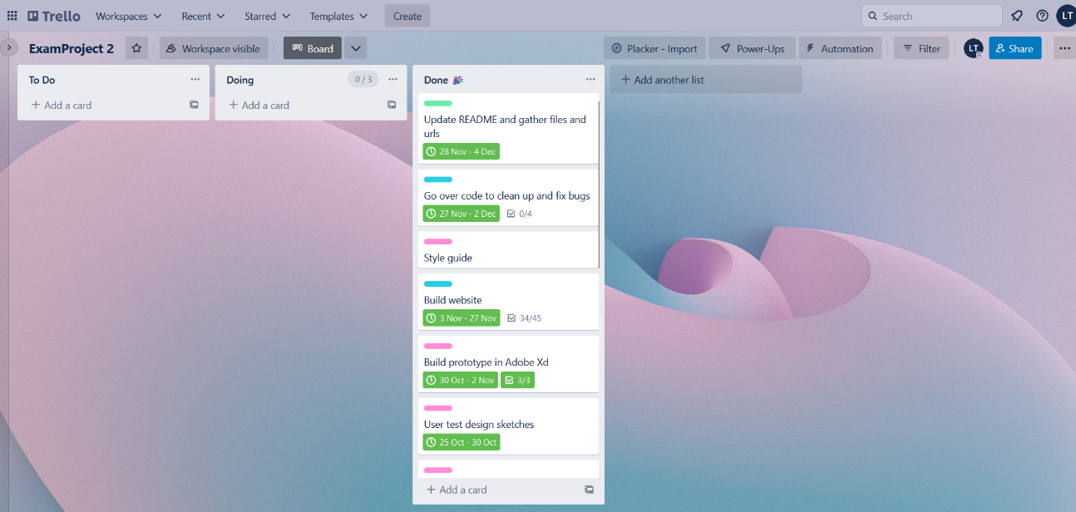

## Appendix 3 Competitor research

I looked into Facebook, Instagram, Twitter, YouTube, LinkedIn, Goodreads, Discord, Twitch, Pinterest and TicTok. I looked at logo, colours, USP, target audience, content types and UI.

This is how I documented my research:

### 3.1 Similarities

* The name tells you what the site specializes in.
* Names and logos are kept short and simple, making them easy to remember.
* Colours and design is kept simple to allow posts/user content to pop.
* Navigation is kept simple and is it easy to find feed, user profile and search bar.
* Some sites use filters actively.
* Sites connected to the gaming community (Discord and Twitch) are more colourful and busy.
* Sites with a larger variety of users are kept more serious and simple (Facebook and LinkedIn).
* Landing pages are often the login page with link to sign up.
* Profile pages are kept simple with profile photo and posts/info.

### 3.2 Takeaways

* Name needs to be short and to the point.
* Branding should center around a clear specialization.
* Styling needs to be clear, modern and simple to allow posts to pop.
* Content types here are text and images, and the rest of the design should reflect that.
* Follow established layout for profile, feed and login.
* USP: A small and familiar community to share content with.
* USP: Simple and clutter free ui, making it easy to navigate and stay updated.

## Appendix 4 Target audience and Personas

### 4.1 Background

* Targeting a young audience.
* Targeting an audience used to social media, who have certain expectations to functionality and styling.
* Posts need to be in focus, and content need to be able to vary in media type and theme.

### 4.2 Target audience for PlotTwist

* Young adults 25 - 35 yo.
* Students or early in their work life.
* Tech savvy and used to navigating social media.
* Spend a significant part of their day on social media.
* Are looking to stay updated on the world around them and connect to others.
* Are looking to be entertained and get a bread from reality.
* Expects a modern front.
* Expects a familiar and easy UI.
* Expecting to be able to follow accounts/profiles, in order to build their own feed.
* Expects to be able to present themselves the way they want, with image and name selected by them.

### 4.3 Personas

## Appendix 5 Wireframes and early sketches

Example of an early wireframe made for this project, showing what later became the feed page on mobile.

I also spent some time choosing things like name and layout, trying out different options.

## Appendix 6 Style tile

### 6.1 Earlier style tile

### 6.2 Final style tile

